You are invited because you are a Potential Ligas Class Member or the guardian of a Potential Ligas Class Member.
During the meeting you will learn about:

- The Ligas Consent Decree
- What makes you or the person for whom you are guardian a Potential Class Member
- Your rights as a Potential Class Member to have a choice in where you live and receive services
- What options you have as a Potential Class Member to continue to live in your current home or move to a different home
www.c-q-l.org/Ligas

The meetings are being held throughout the state to offer you an opportunity to learn about the Ligas Consent Decree. If you are interested but unable to attend any of the meetings listed on the back of this invitation, please call:
(816) 662-2225
We hope you will take advantage of this opportunity to learn about the Ligas Consent Decree and what that means to you as a Potential Class Member or the guardian of a Potential Class Member.
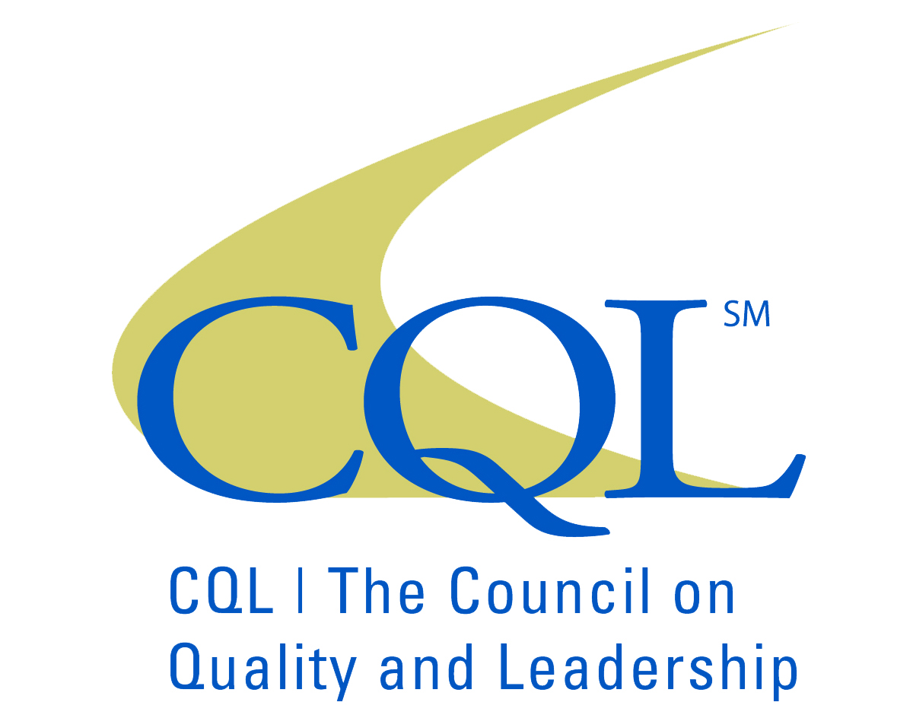 | The meeting is hosted by CQL | The Council on Quality and Leadership, on behalf of the State of Illinois, Department of Human Services.
  Western Illinois Service Coordination  3PM  TUE  9/29  509 N. Lafayette St. STE 203  7PM  WED  10/7  Macomb, IL 61455 |  |  | PACT, Inc.  750 Warrenville Rd. STE 300  Lisle, IL 60532
Holiday Inn Express  3PM  THUR  10/8  7PM  TUE  9/29  2501 Holiday Lane  Jacksonville, IL 62560 |  |  | Community Service Options  6845 South Western Ave  Chicago, IL 60636
Champaign County Regional Planning Commission  3PM  WED  9/30  7PM  THUR  10/8  1776 E. Washington Street  Urbana, IL 61802 |  |  | Community Alternatives Unlimited  8765 West Higgins Rd 3rd Floor  Chicago, IL 60631
Central Illinois Service Access  2PM  FRI  10/9  7PM  WED  9/30  101 Madigan Dr.  Lincoln, IL 62656 |  |  | Service, Inc.  1740 McDonough St.  Joliet, IL 60436
Prairieland Service Coordination  3PM  TUE  10/13  3PM  THUR  10/1  100 S. Water St. Suite 220 M  Decatur, IL 62523 |  |  | CSO/RIM  3601 Morton Drive STE 1  East Moline, IL 61244
Access Services of Northern IL  7PM  WED  10/13  3PM  TUE  10/6  Child and Family Connections  1752 Windsor Rd. STE 100  Loves Park, IL 61111 |  |  | Pittsfield Community Center  224 W. Washington  Pittsfield, IL 62363
Options & Advocacy of McHenry County  7PM  TUE  10/6  3PM  WED  10/14  365 Millennium Dr.  Crystal Lake, IL 60012 |  |  | Southern Illinois Case Coordination Services  140 South Locust St  Centralia, IL 62801
DayOne Network  7PM  WED  10/14  3PM  WED  10/7  1551 East Fabyan Pkwy  Geneva, IL 60134 |  |  | DD Services, Metro East  2900 Frank Scott Parkway West STE 928  Belleville, IL 62223
 |  | If you are unable to attend a meeting, please call us for accommodations:  (816) 662-2225

