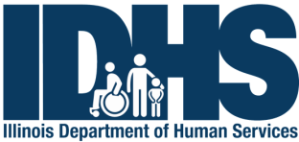

Recovery & Empowerment

Statewide Call Evaluation

Title: Living Well on a Shoestring Budget Date: Oct. 24, 2019

Thank you for participating in the Recovery & Empowerment Statewide Call. We would appreciate you completing the following brief evaluation to let us know about your experience as a participant.

Please rate (circle) the following on a scale of “5" to “1", with “5" indicating that you very much agree and “1" that you don’t agree at all.

Very Much

Somewhat

Undecided

Not Really

Not At All

1. The educational content was relevant to my situation.

2. The presentation was respectful of the diverse experiences of participants.

3. The education and support provided will help me cope better with challenges.

4. The education and support provided will help me find my own ideas for staying well or improving my life.

5. The education and support provided will help me to be involved in or take charge of my own mental health and wellness.

6. Overall, I was satisfied with the call.

7. I would recommend these statewide calls to others.

5 4 3 2 1

5 4 3 2 1

5 4 3 2 1

5 4 3 2 1

5 4 3 2 1

5 4 3 2 1

5 4 3 2 1

COMMENTS: ____________________________________________________________________________________________________________________________________________________________________________________
______________________________________________________________________________________________________________________________________________________________________________________________________________________________________________________________________________
____________________________________________________________________________________________________________________________________________________________________________________

For Comments or Questions: 1-866-359-7953 – Select “The Warm Line”
Submit Evaluation to: Fax: Christal Hamm at (309) 346-2542 OR email at
DHS.DMHRecoveryServices@illinois.gov OR mail to 200 S. 2nd Street, Suite 20, Pekin, IL 61554

